Central Bank
# Source: AI Source: Provided by: [Data Path: Persons Table -> ID Column: 1, Name_En Column: Motasem Essam] -> From: [ChatGPT] on [1/21/2026]
A central bank plays a critical role in the national and global payment system infrastructure by acting as a regulator, operator, and overseer of how money moves between banks, financial institutions, and payment providers. Its main function is to ensure stability, security, and efficiency of the financial system.

🧠 Simple Definition
# Source: AI Source: Provided by: [Data Path: Persons Table -> ID Column: 1, Name_En Column: Motasem Essam] -> From: [ChatGPT] on [1/21/2026]
The central bank is the authority responsible for supervising, regulating, and supporting the infrastructure that enables secure, reliable, and legal payment transactions within a country.

🎯 Key Roles of the Central Bank in Payment Systems
# Source: AI Source: Provided by: [Data Path: Persons Table -> ID Column: 1, Name_En Column: Motasem Essam] -> From: [ChatGPT] on [1/21/2026]
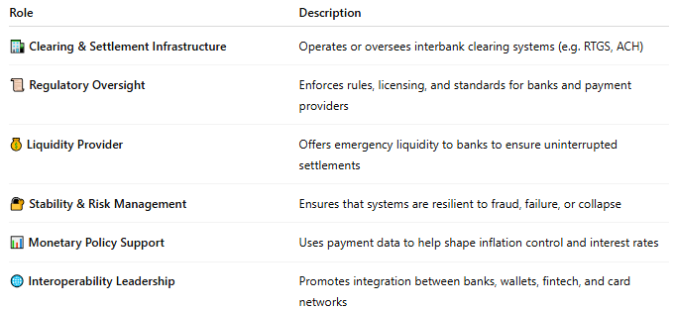
Role | Description
🏦 Clearing & Settlement Infrastructure | Operates or oversees interbank clearing systems (e.g. RTGS, ACH)
📜 Regulatory Oversight | Enforces rules, licensing, and standards for banks and payment providers
💰 Liquidity Provider | Offers emergency liquidity to banks to ensure uninterrupted settlements
🔐 Stability & Risk Management | Ensures that systems are resilient to fraud, failure, or collapse
📊 Monetary Policy Support | Uses payment data to help shape inflation control and interest rates
🌐 Interoperability Leadership | Promotes integration between banks, wallets, fintech, and card networks

🔄 Functions in the Payment Ecosystem
# Source: AI Source: Provided by: [Data Path: Persons Table -> ID Column: 1, Name_En Column: Motasem Essam] -> From: [ChatGPT] on [1/21/2026]
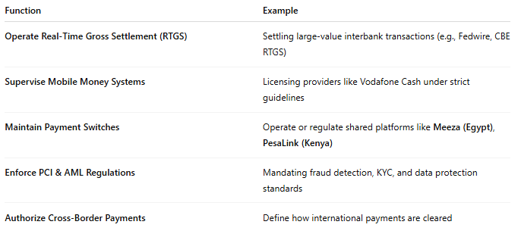

Function | Example
Operate Real-Time Gross Settlement (RTGS) | Settling large-value interbank transactions (e.g., Fedwire, CBE RTGS)
Supervise Mobile Money Systems | Licensing providers like Vodafone Cash under strict guidelines
Maintain Payment Switches | Operate or regulate shared platforms like Meeza (Egypt), PesaLink (Kenya)
Enforce PCI & AML Regulations | Mandating fraud detection, KYC, and data protection standards
Authorize Cross-Border Payments | Define how international payments are cleared

🌍 Examples of Central Banks in Action
# Source: AI Source: Provided by: [Data Path: Persons Table -> ID Column: 1, Name_En Column: Motasem Essam] -> From: [ChatGPT] on [1/21/2026]
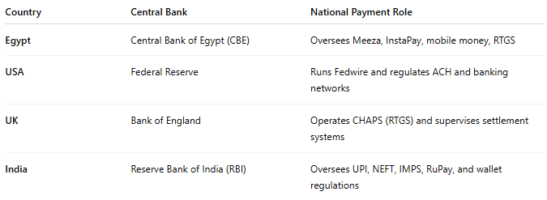

Country | Central Bank | National Payment Role
Egypt | Central Bank of Egypt (CBE) | Oversees Meeza, InstaPay, mobile money, RTGS
USA | Federal Reserve | Runs Fedwire and regulates ACH and banking networks
UK | Bank of England | Operates CHAPS (RTGS) and supervises settlement systems
India | Reserve Bank of India (RBI) | Oversees UPI, NEFT, IMPS, RuPay, and wallet regulations

✅ Why the Central Bank Is Important
# Source: AI Source: Provided by: [Data Path: Persons Table -> ID Column: 1, Name_En Column: Motasem Essam] -> From: [ChatGPT] on [1/21/2026]
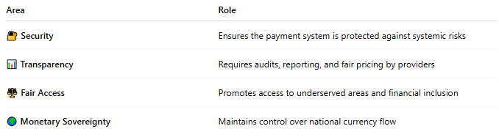

Area | Role
🔐 Security | Ensures the payment system is protected against systemic risks
📊 Transparency | Requires audits, reporting, and fair pricing by providers
⚖️ Fair Access | Promotes access to underserved areas and financial inclusion
🌍 Monetary Sovereignty | Maintains control over national currency flow

🧠 Summary
# Source: AI Source: Provided by: [Data Path: Persons Table -> ID Column: 1, Name_En Column: Motasem Essam] -> From: [ChatGPT] on [1/21/2026]
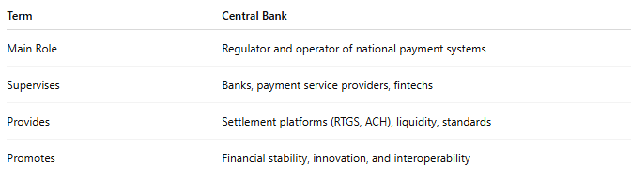

Term | Central Bank
Main Role | Regulator and operator of national payment systems
Supervises | Banks, payment service providers, fintechs
Provides | Settlement platforms (RTGS, ACH), liquidity, standards
Promotes | Financial stability, innovation, and interoperability

